LUXURY STAY

(Hotel Management)

(DESIGN GUIDE)


GROUP MEMBERS

Student 1571110 | Naveera Hanif
Student 1571109 | Mahnoor
Student 1501307 | Sunaina Shahid
Student 1547290 | Syeda Shama Iqbal


CURRICULUM: ACCP PRIME 2.0
SEMESTER: ADSE
FACULTY: Sir Muhammad Noman Siddiqui

CERTIFICATE OF RECOGNITION

This certificate is awarded to the developers of LuxuryStay for their outstanding contribution to the world of Fintech and Digital Innovation.

The recognition of LuxuryStay refers to an award for its achievements in providing real-time exchange rates, seamless currency conversion, and an exceptional user experience. This includes factors such as ensuring data accuracy, promoting financial transparency, and providing accessible tools for global users.
A recognition of this kind serves as a testament to the hard work and dedication of the LuxuryStay development team and management, and helps to establish LuxuryStay as a leader in the digital currency solutions industry.


15-Oct-2026
PRESENTED ON:

FACULTY:
SIR NOMAN SIDDIQUI

ACKNOWLEDGEMENT

We would like to express our sincere gratitude to everyone who has contributed to the successful completion of this project.

Our heartfelt thanks goes to Sir Noman for providing invaluable guidance and support throughout the whole process.
We are deeply grateful to our group members for their hard work, dedication, and collaboration. Their efforts have been instrumental in bringing LuxuryStay to fruition.
We would also like to thank our families for their love and support, which has allowed us to stay focused and motivated.
Finally, we extend our thanks to all those who have provided us with the resources and opportunities necessary to complete this project.
This project would not have been possible without the help and support of all of you. THANK YOU.

SYNOPSIS:
LuxuryStay is a digital solution designed to provide real-time room bookings, personalized guest services, and seamless reservation management for travelers and hotel administrators. The platform aims to elevate the hospitality experience by offering up-to-date information on room availability, luxury amenities, and pricing through an intuitive and user-friendly interface. LuxuryStay hosts all the necessary information about premium room categories, guest services, and special promotional packages available to the user.

Categories:

LuxuryStay offers comprehensive tools to browse, reserve, and manage hotel accommodations with ease and precision. Users can explore a wide range of luxury suites, dining options, and exclusive hotel amenities tailored to provide the best hospitality insights and experience.
- Simple Booking Process: Select your preferred dates, choose your room category, view real-time pricing and availability, and confirm your reservation. And you are done!

Distribution:
You can access our platform from anywhere in a very convenient and secure way. Guests can view their past booking history, manage upcoming reservations, and explore live concierge services for a guaranteed luxury stay confirmation.
PROBLEM STATEMENT:
LuxuryStay is a high-end hotel chain known for its exceptional service and luxurious accommodations. Currently, hotel management operations face difficulties in streamlining room reservations, real-time status updates, and centralized guest management across multiple hotel locations through a single, reliable platform.
To solve this, LuxuryStay aims to implement a modern, responsive, and scalable digital web application. The platform centralizes all room inventory management, real-time availability tracking, guest services, dynamic billing, and automated system notifications to elevate operational efficiency and guest experience.
Requirement Speification:
Based on the core functional specifications of the LuxuryStay application, the system is designed with the following key features:
- Home & Landing Page: Displays the brand logo, hero banner, featured luxury rooms/suites, key amenities, and an interactive real-time room availability checker.
- Navigation & Accessibility: A responsive navigation menu containing options for Home, Rooms & Suites, Reservations/History, Services, and User Profile sections for seamless user navigation.
- Room Booking & Inventory Logic: Allows guests and staff to filter and choose from a variety of room categories (e.g., Deluxe, Executive, Suite), view real-time pricing and availability status (Available, Occupied, Cleaning), and make instant reservations.
- Live System Notification System: Integrated real-time alerts for staff regarding new room bookings, guest requests, and maintenance updates, complete with a dynamic badge count on the notification icon.
- Historical Reservation Tracking: Every time a user or receptionist confirms a booking or check-in/out, all reservation details and transaction records are securely stored in the cloud database (MongoDB / Firestore) for future reference and guest history tracking.
- Visual Analytics & Reporting: An integrated management dashboard providing visual insights (charts/graphs) on occupancy rates, 7-day revenue trends, and overall guest feedback analytics.
- User & Profile Management: Dedicated User/Staff Profile pages where users can manage account details, update profile preferences, view past booking histories, and securely sign out with role-based access control.


SITE MAP:

HOME (Landing Page)

----------------+--------------+--------------------------------- ---+--------------------------+------
| | | |
[ ROOMS & SUITES ] [ ABOUT US ] [ SERVICES & AMENITIES ] [ CONTACT US ]
|
[ Room Details & Availability ]
|
[ Book Now / Reservation Form ]
|
[ Payment & Confirmation ]

[ USER DASHBOARD ]

+----------------------+-----------------------------+---------------------------------+
| | | |
[ MY RESERVATIONS ] [ PROFILE ] [ GUEST REQUESTS ] [ NOTIFICATIONS ]
- Past Bookings - Edit Profile - Room Service - Booking Alerts
- Active Stays - Account Settings - Maintenance Request - Status Updates
- Cancel Booking - Logout - Feedback & Ratings

[ ADMIN / STAFF DASHBOARD ]

+------------------------------------+---------------------------------+--------------------------------+
| | | |
[ ROOM MANAGEMENT ] [ RESERVATION CONTROL ] [ HOUSEKEEPING ] [ ANALYTICS & REPORTS ]
- Inventory Setup - View All Bookings - Cleaning Tasks - Occupancy Rates
- Pricing & Rates - Check-In / Check-Out - Status Updates - Revenue Trends
- Status Tracking - Assign Rooms - Maintenance Logs - Guest Insights
|
[ STAFF PROFILES ]
- Manager, Receptionist, Housekeeping Roles

CHECKLIST OF VALIDATION:

Option | Validation
Do all navigation icons lead to the appropriate screens? | YES
Does the room search & booking system show accurate pricing and availability? | YES
Are all real-time analytics graphs (occupancy/revenue) clearly visible on the dashboard? | YES
Is the web application opening properly across all tested web browsers (Chrome, Firefox, Edge)? | YES
Are notification badges updating in real-time for new bookings and alerts? | YES
Is the user interface responsive on different screen sizes? | YES
Is the application taking too long to load data? | NO
Is the data being stored correctly in the MongoDB database? | YES
Is the logout functionality working as expected? | YES


TASK SHEET:

S  No. | TASK | Member Name | Start Date | Days Used | Status
1 | UI/UX Design | Naveera Hanif, Mahnoor, Sunaina Shahid | 15-Sep-2026 | 5 | COMPLETE
2 | Frontend Development (React.js) | Naveera Hanif,, Sunaina Shahid | 21-Sep-2026 | 7 | COMPLETE
3 | Backend API &  Authentication Setup  (Node.js & Express.js) | Naveera Hanif, Mahnoor | 28-Sep-2026 | 3 | COMPLETE
4 | MongoDb Database &  Schema Integration | Naveera Hanif, Mahnoor, Sunaina Shahid | 1-Oct-2026 | 3 | COMPLETE
5 | Room Booking &  Reseravation Module | Naveera Hanif, Sunaina Shahid | 3-Oct-2026 | 4 | COMPLETE
6 | Admin Dashboard  & Analytics Charts | Naveera Hanif, Mahnoor, Sunaina Shahid | 6-Sep-2026 | 2 | COMPLETE
7 | Testing, Bug Fixing  Optimization | Mahnoor, Sunaina Shahid | 7-Sep-2026 | 1 | COMPLETE

S  No. | TASK | Member Name | Start Date | Days Used | Status
8 | Profile Management | Naveera Hanif, Mahnoor, | 9-Oct-2026 | 2 | COMPLETE
9 | Final Documentation & Testing | Mahnoor, Sunaina Shahid | 12-Oct-2026 | 3 | COMPLETE

SIGN UP / LOGIN FORM:
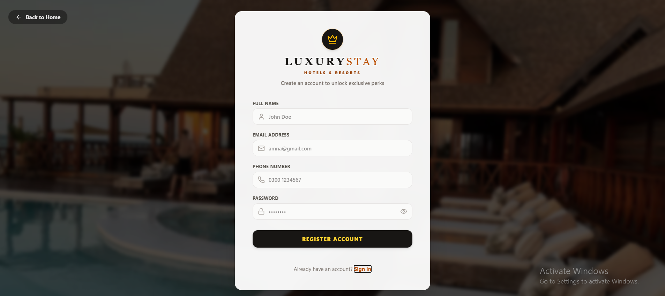

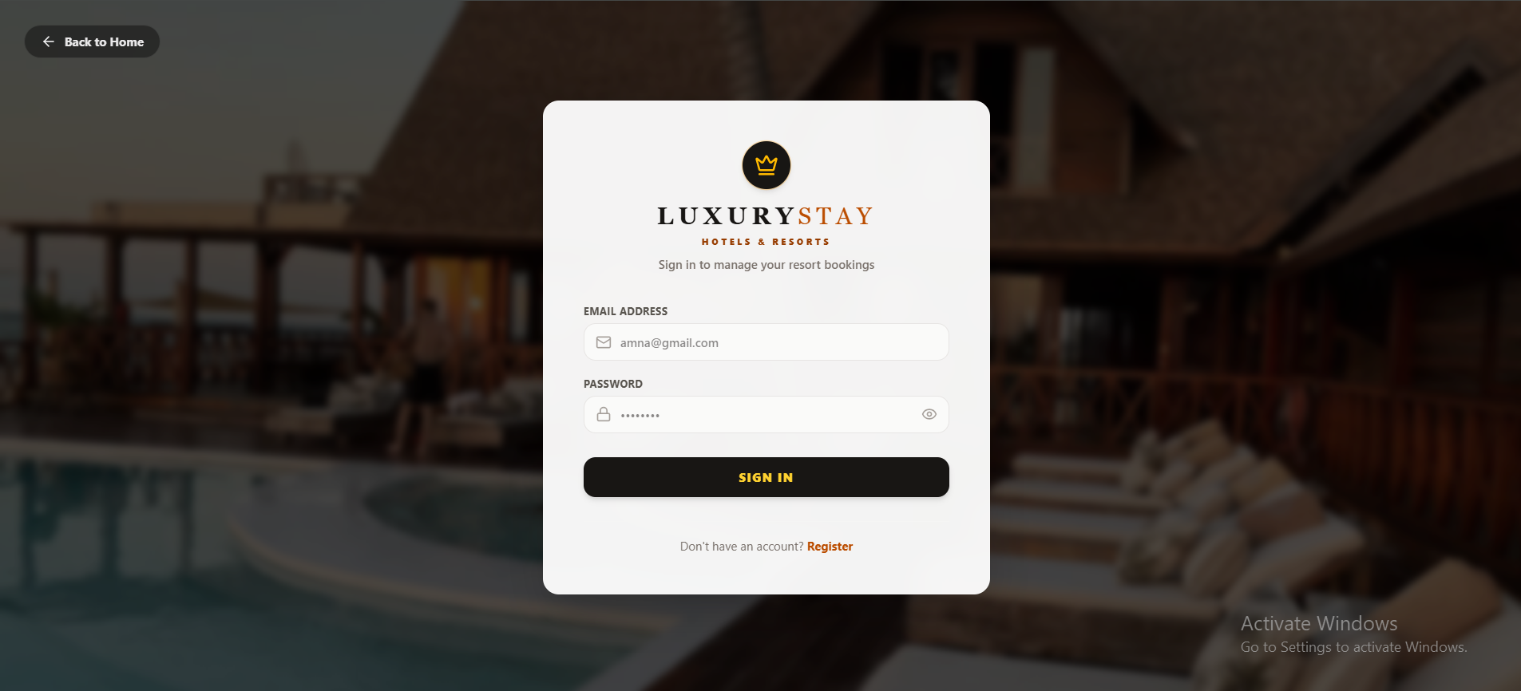

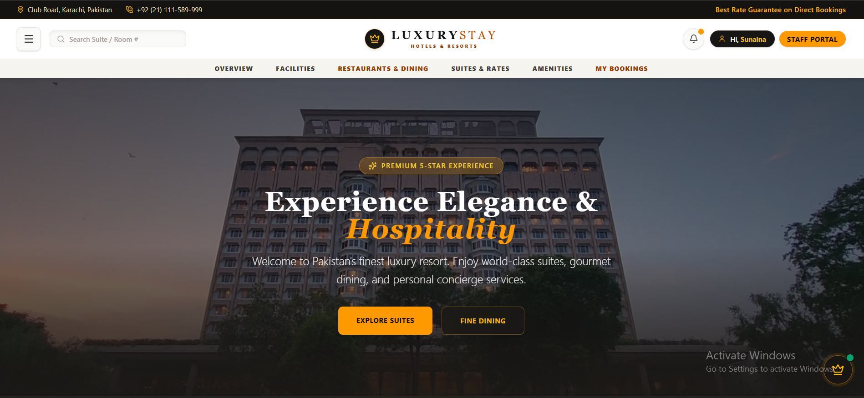
HOME PAGE:

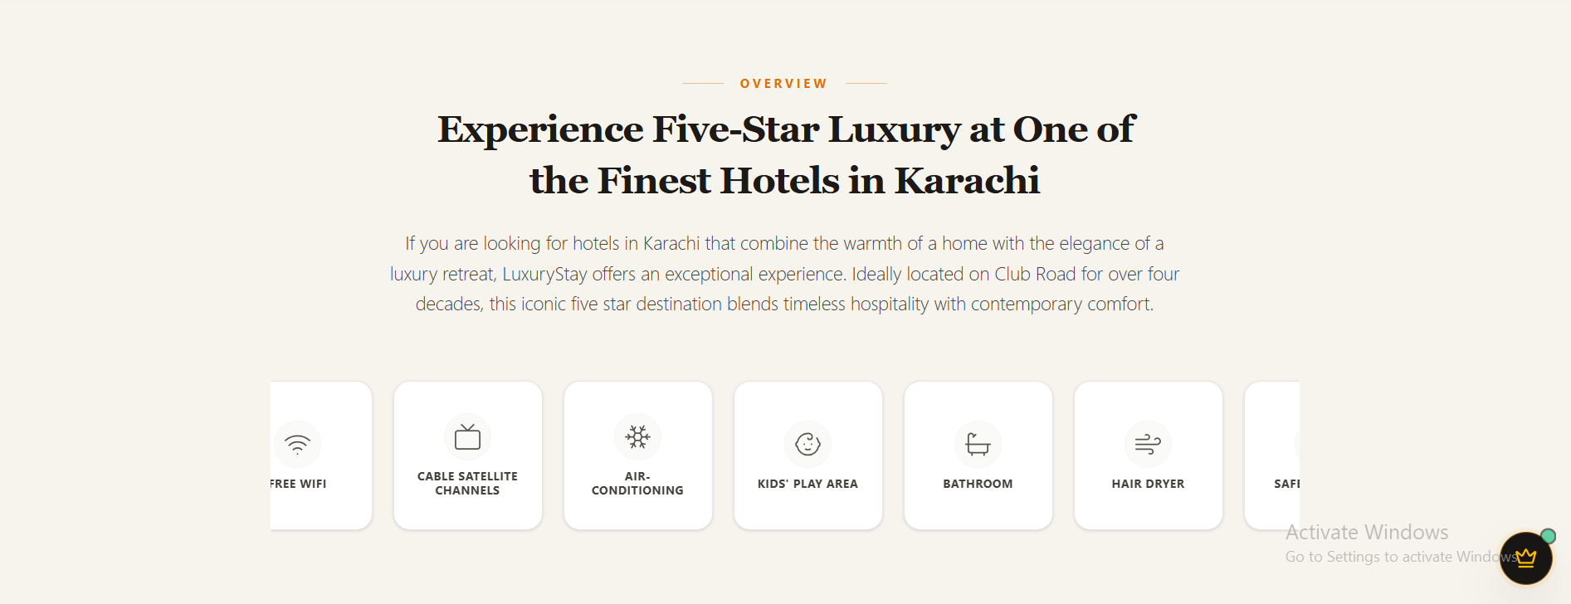

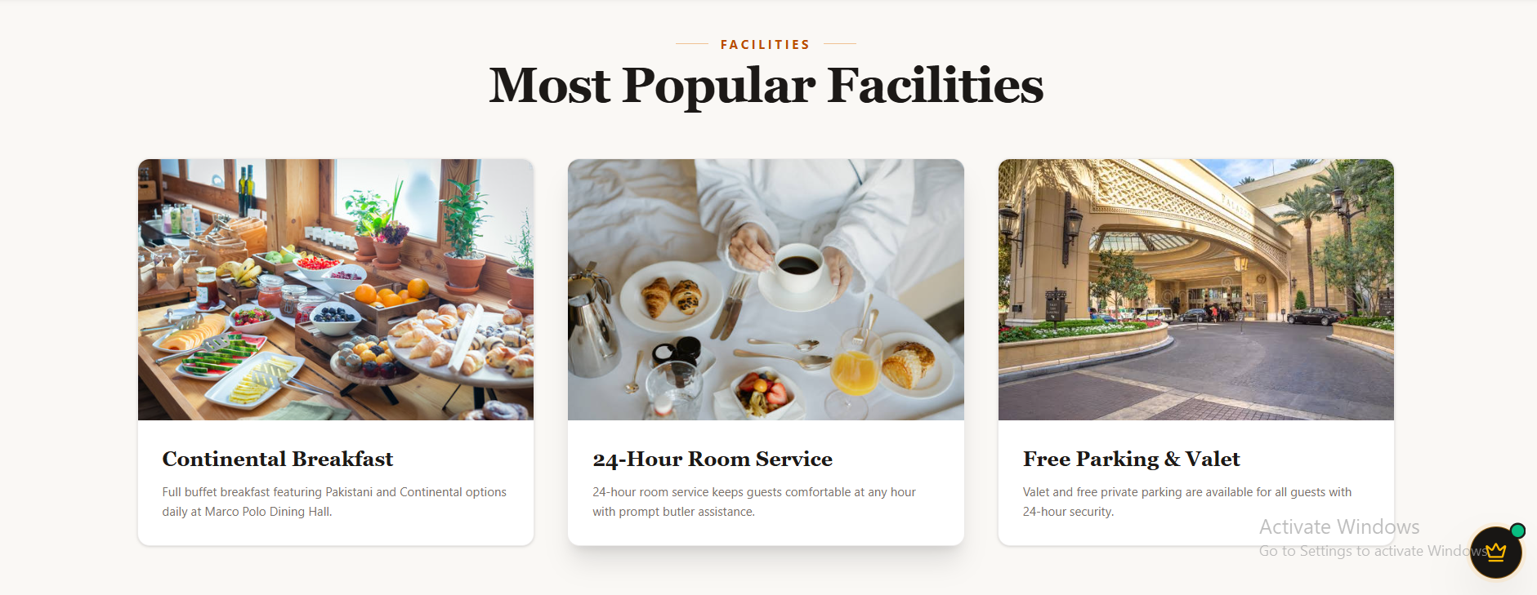

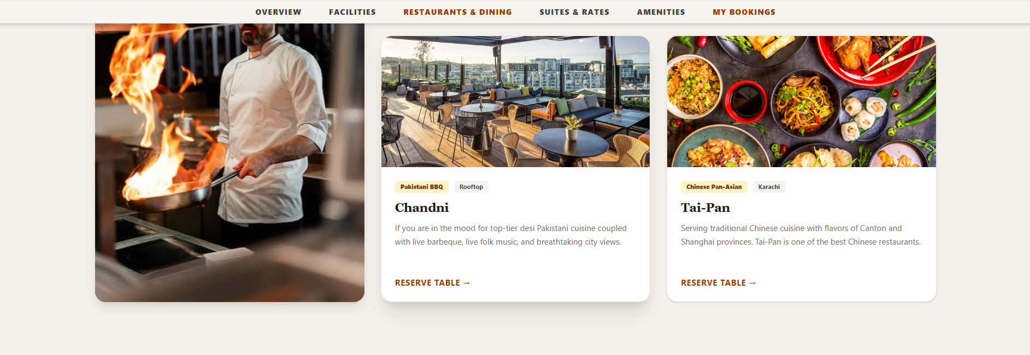
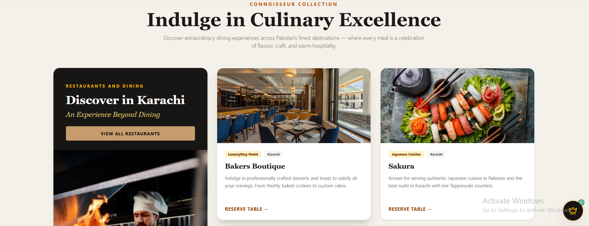

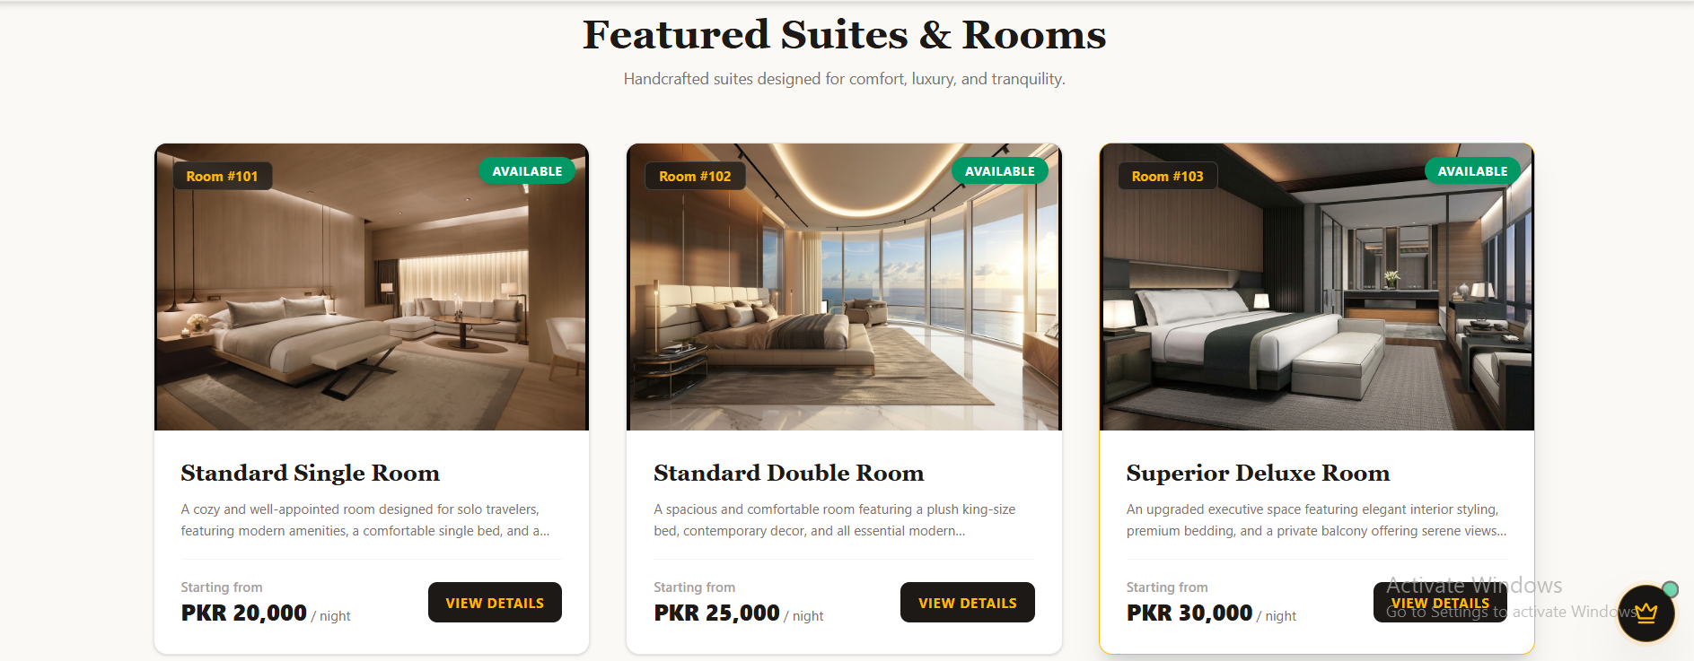

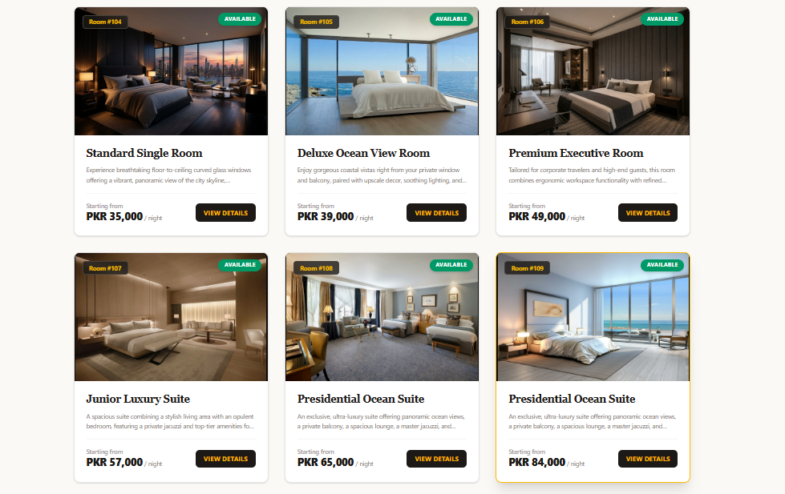
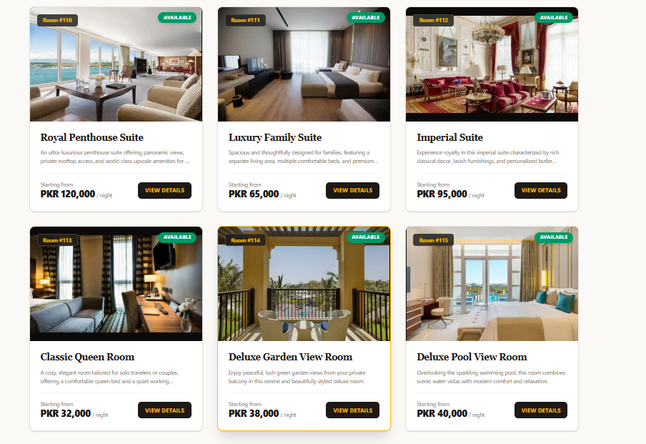

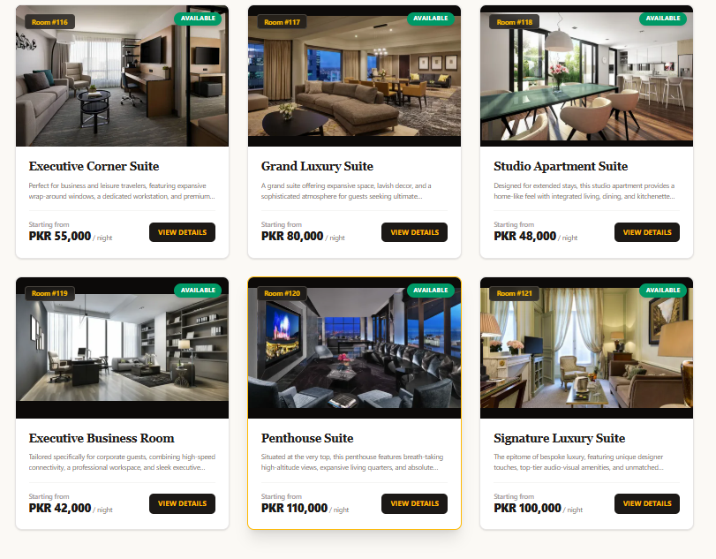

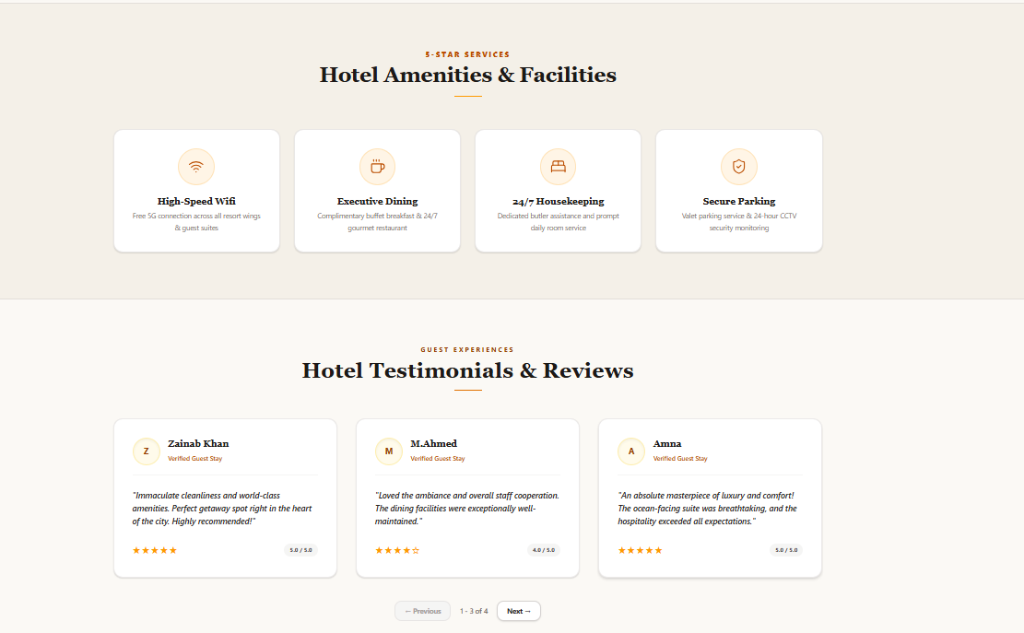

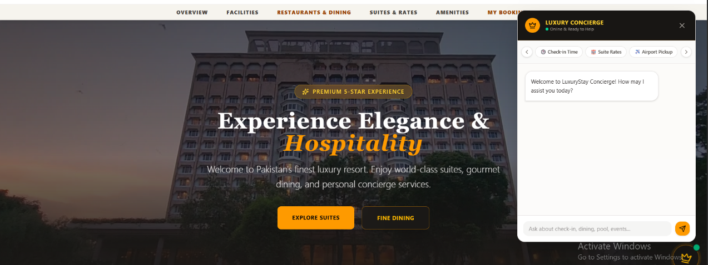

CHATBOT:

FOOTER:
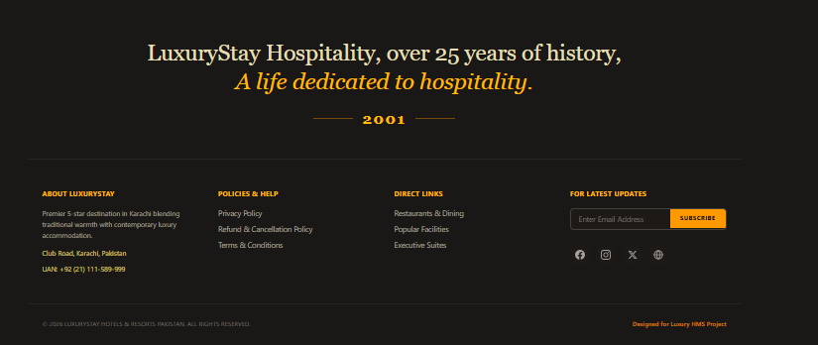

Side Bar

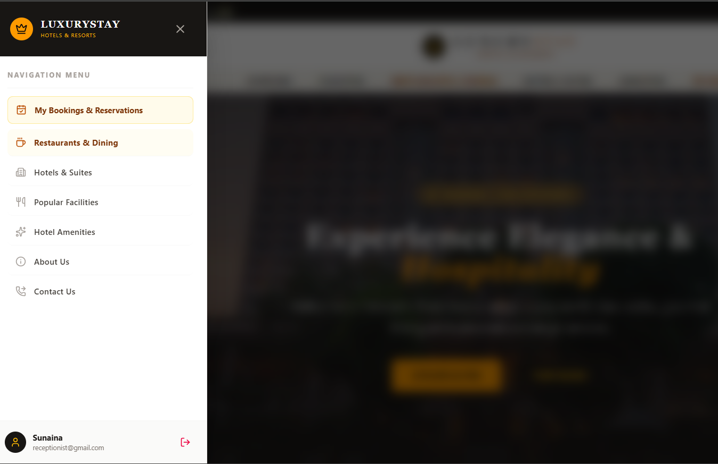

Bookings:
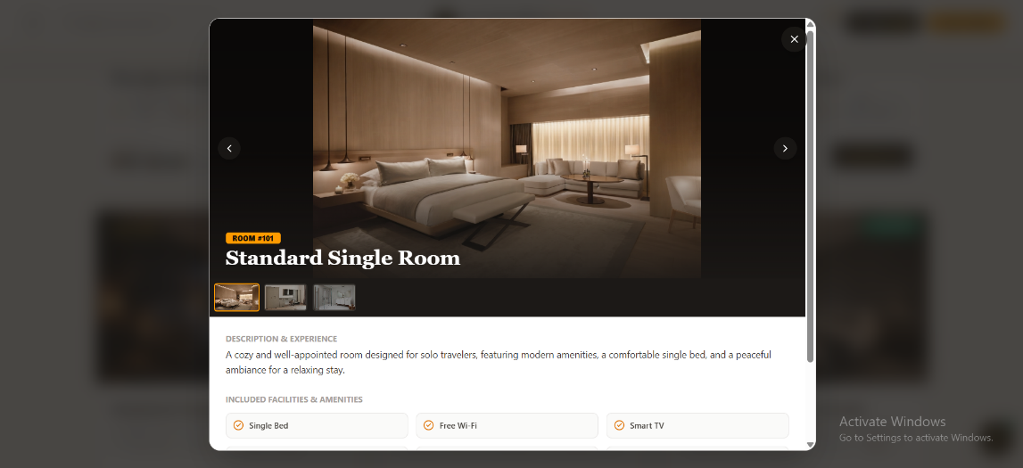

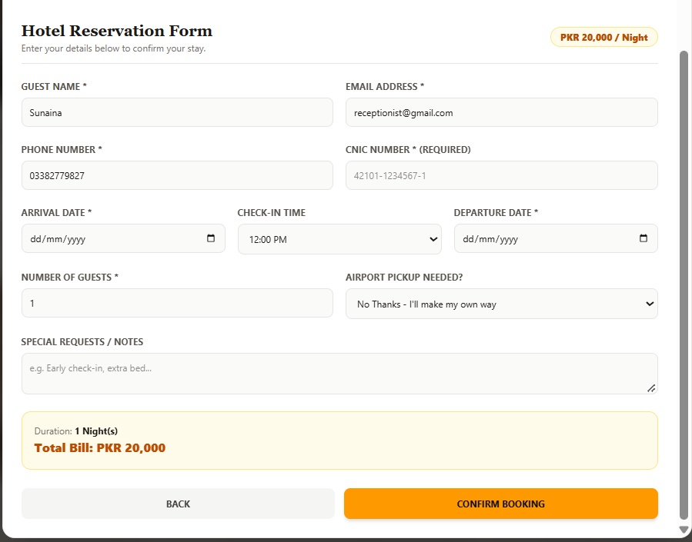
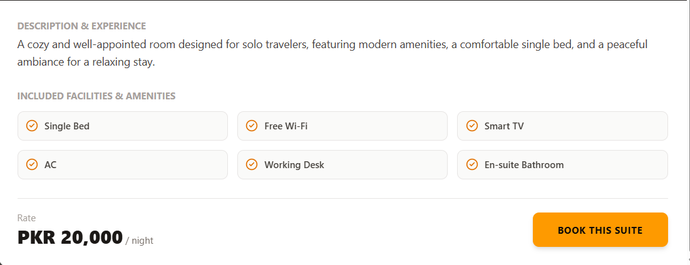
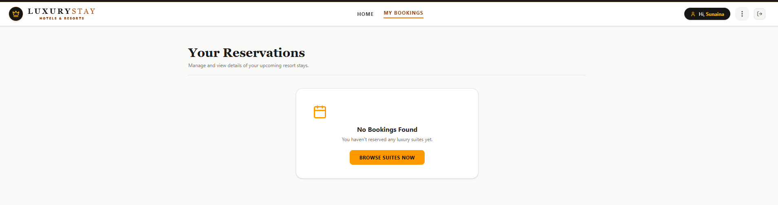

ABOUT PAGE:
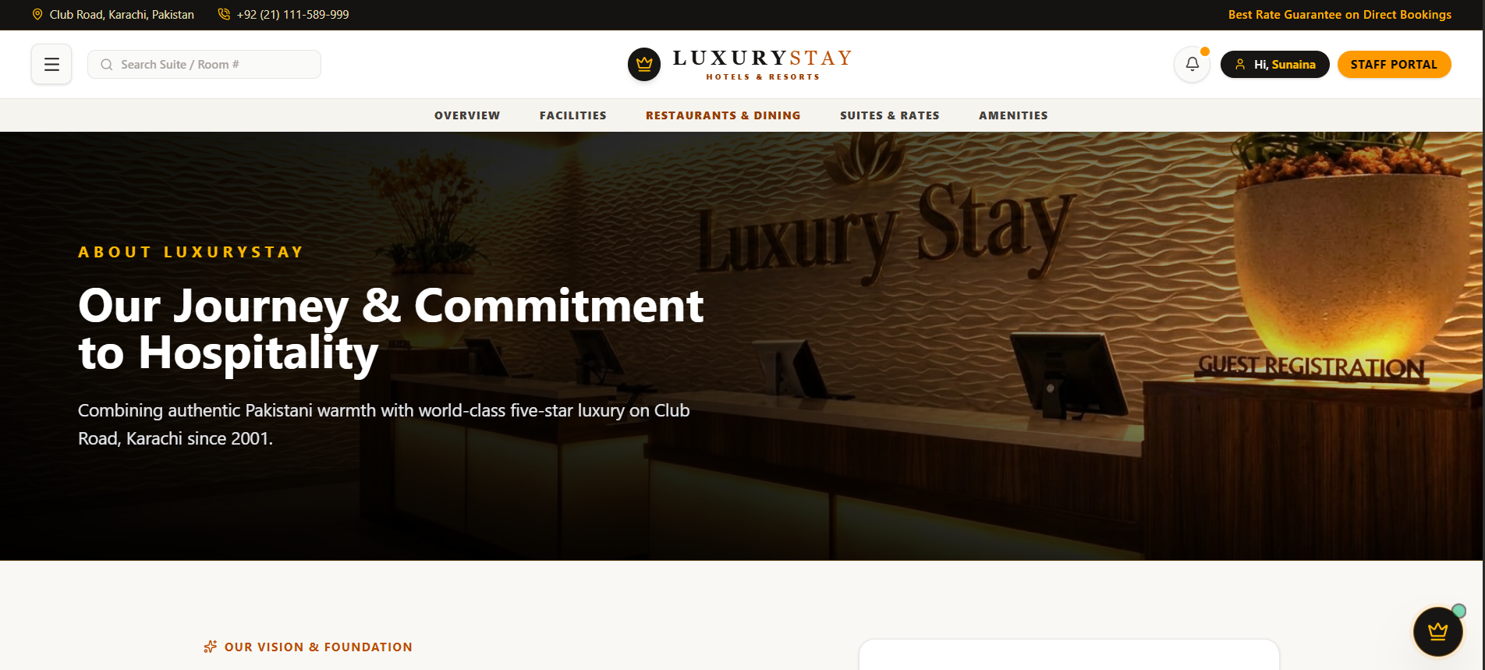
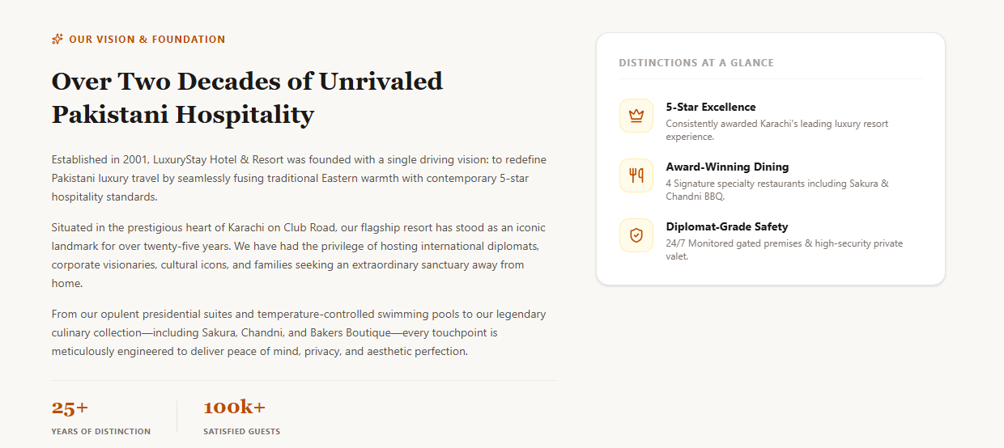

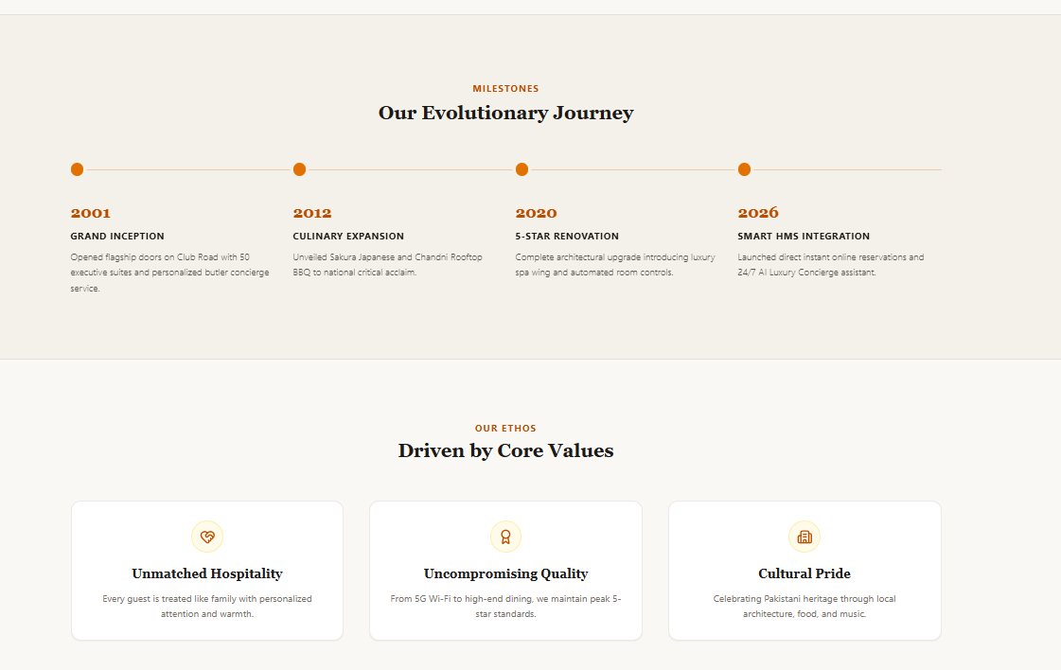

CONTACT PAGE:

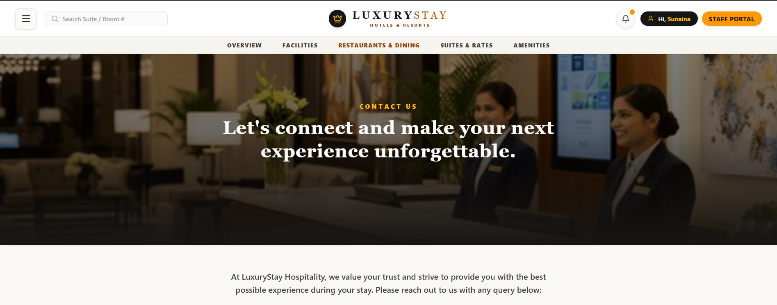
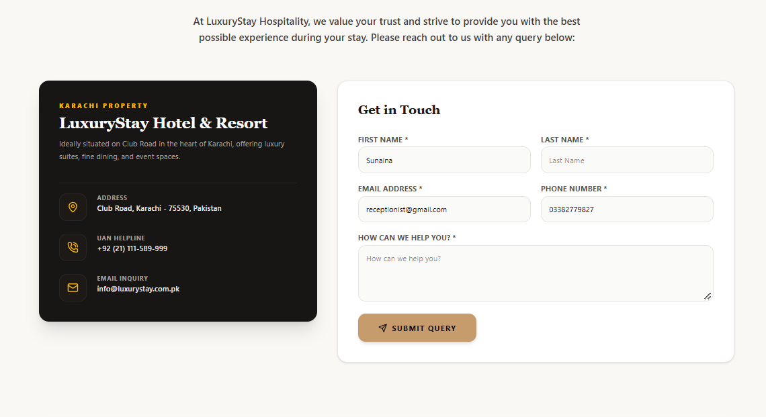

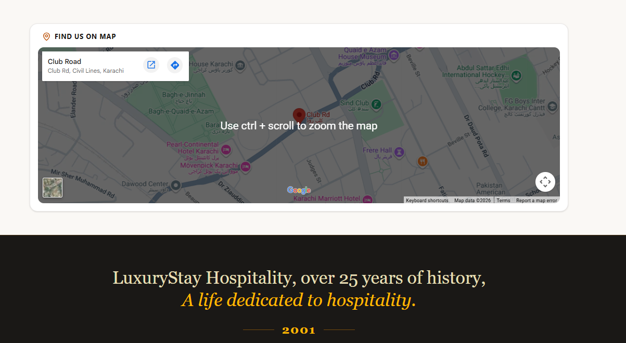

ADMIN PANEL:
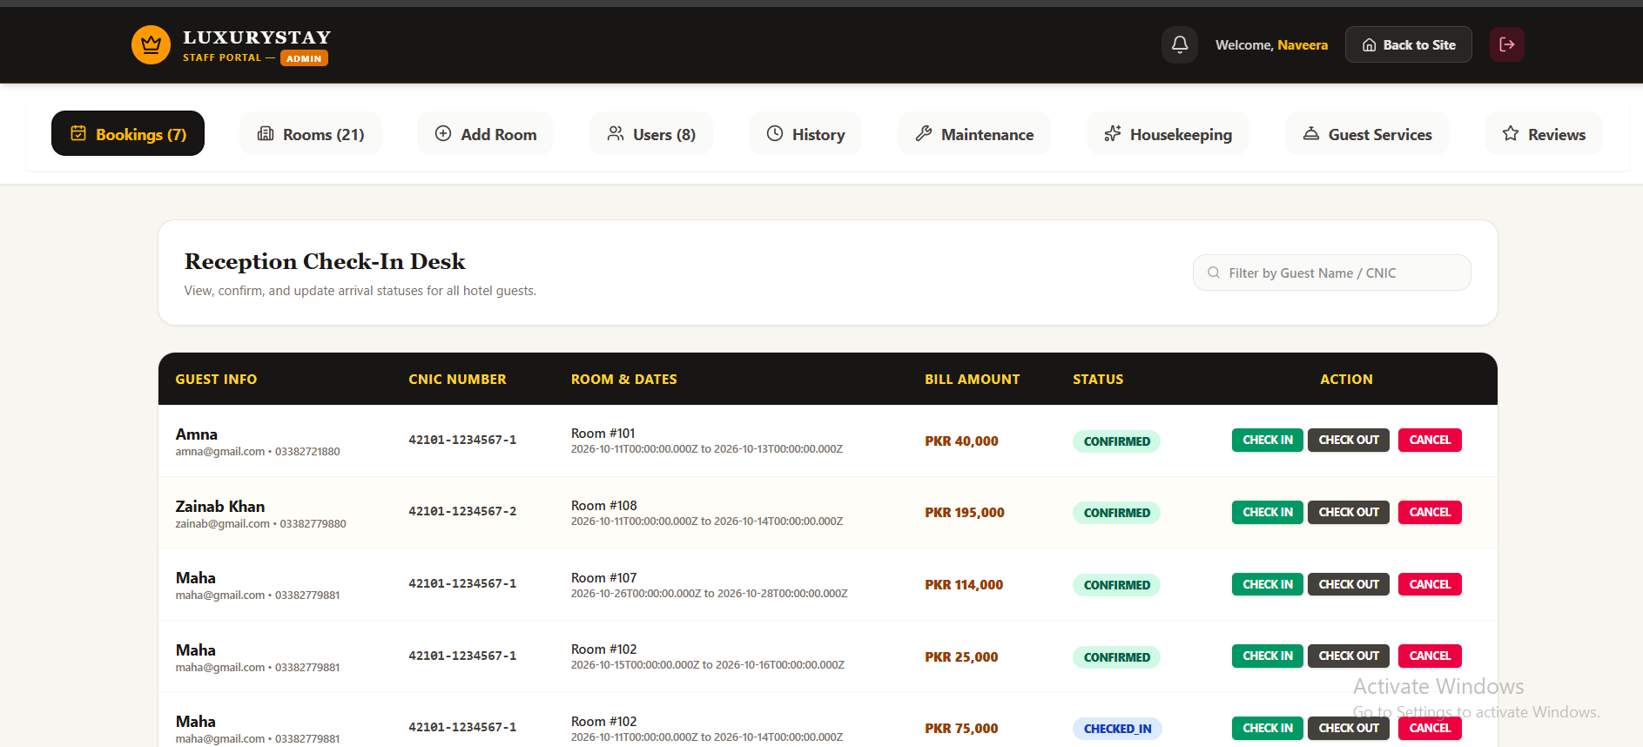

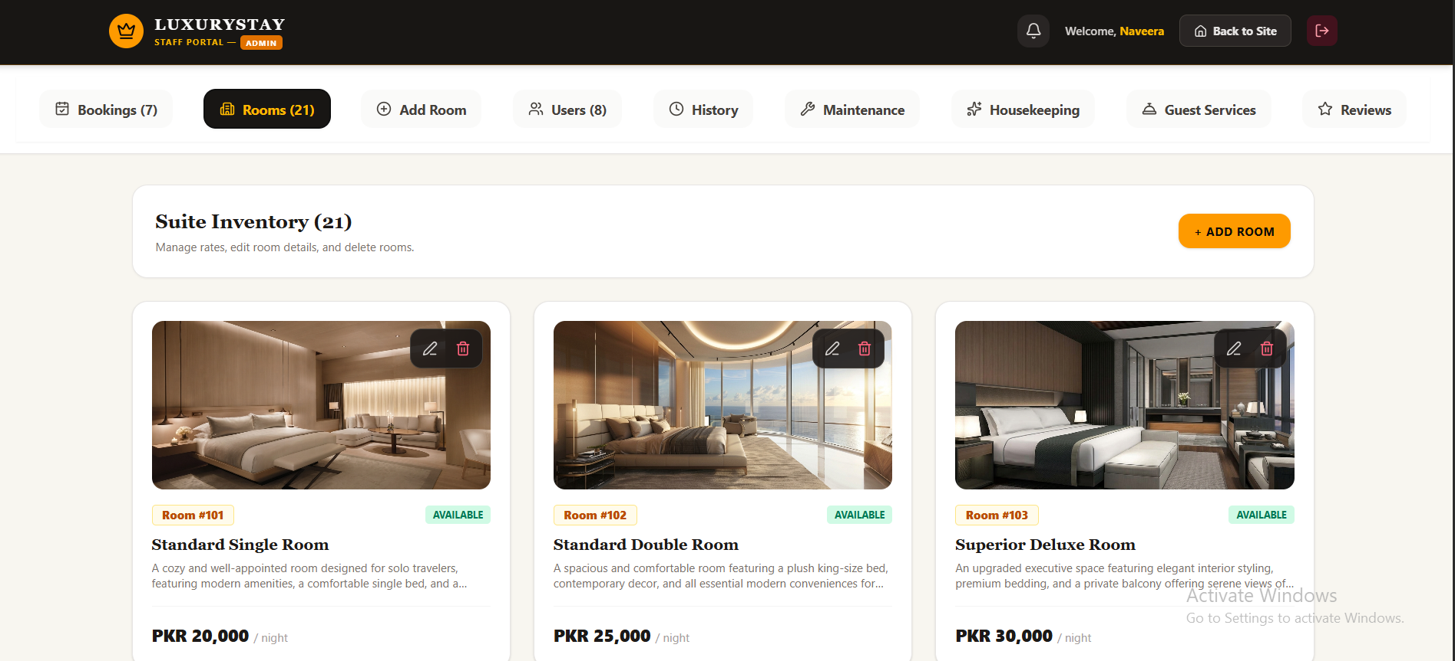
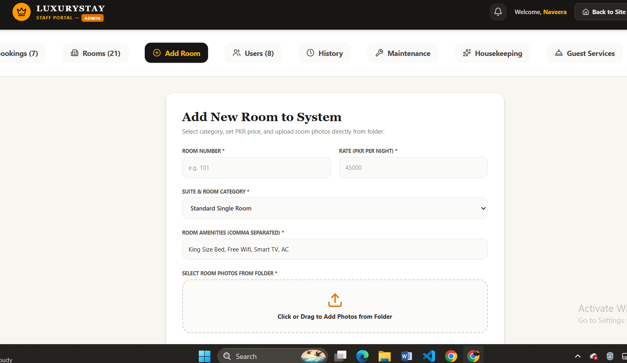

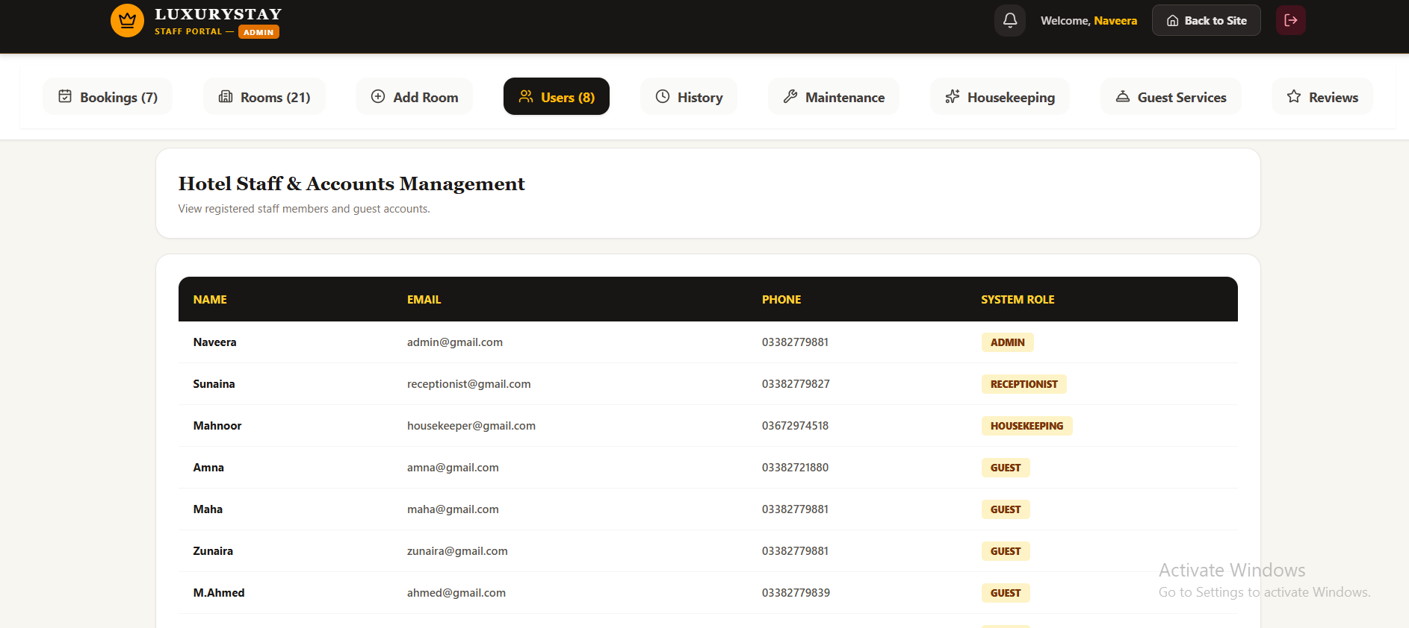

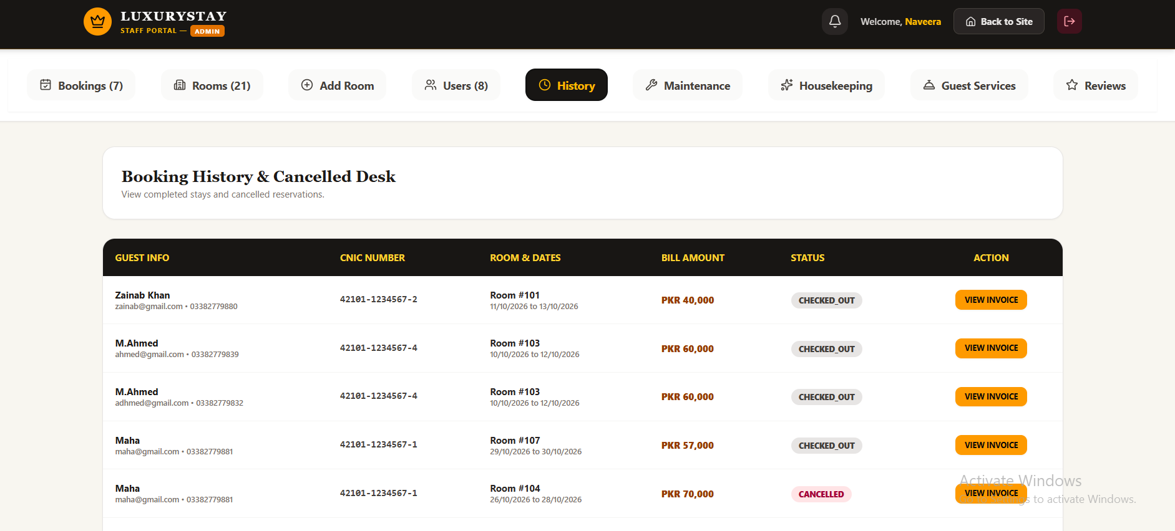
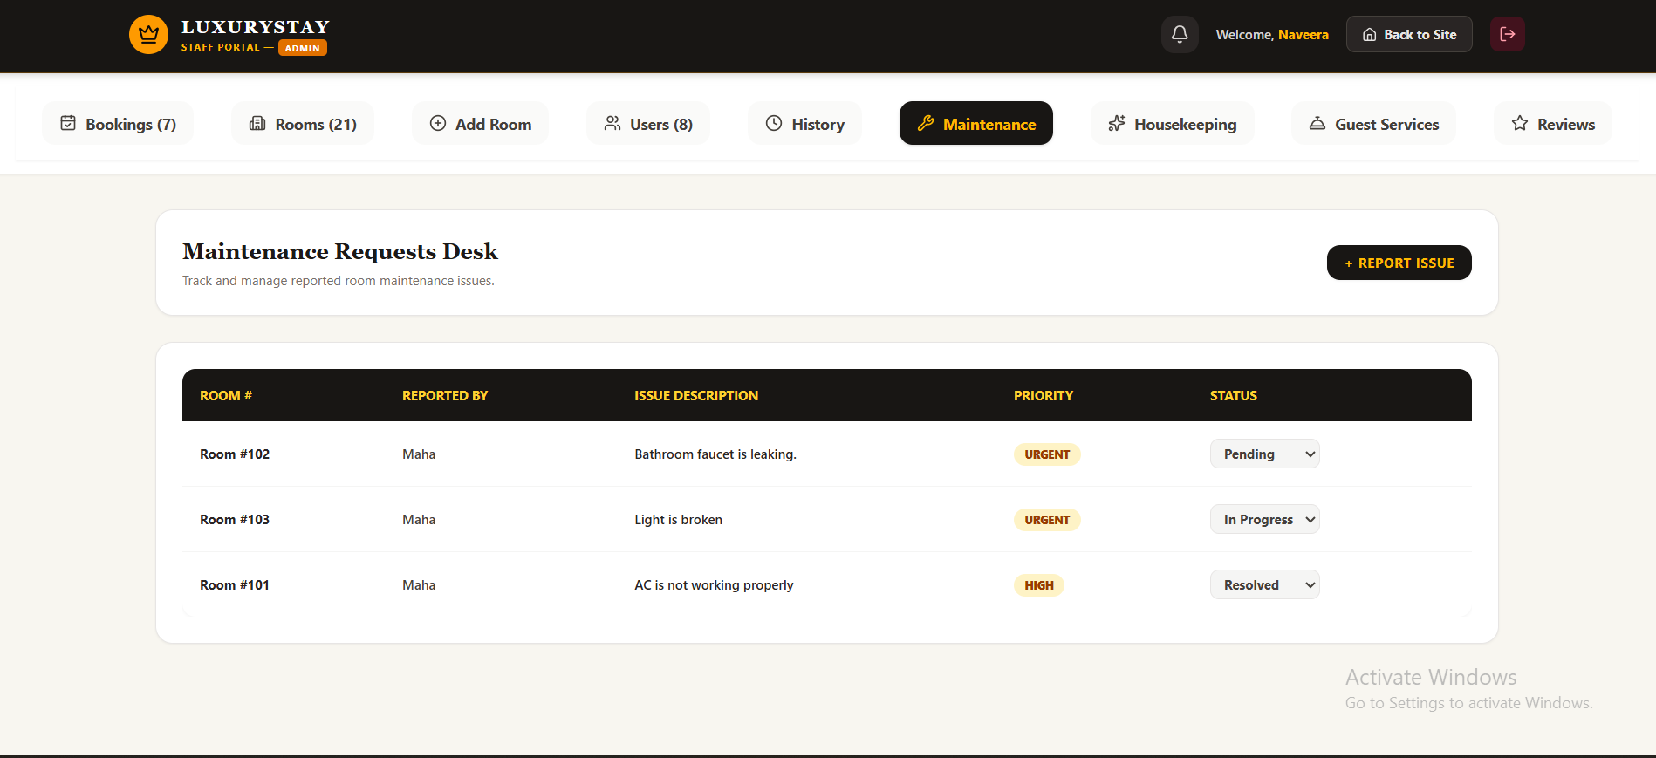

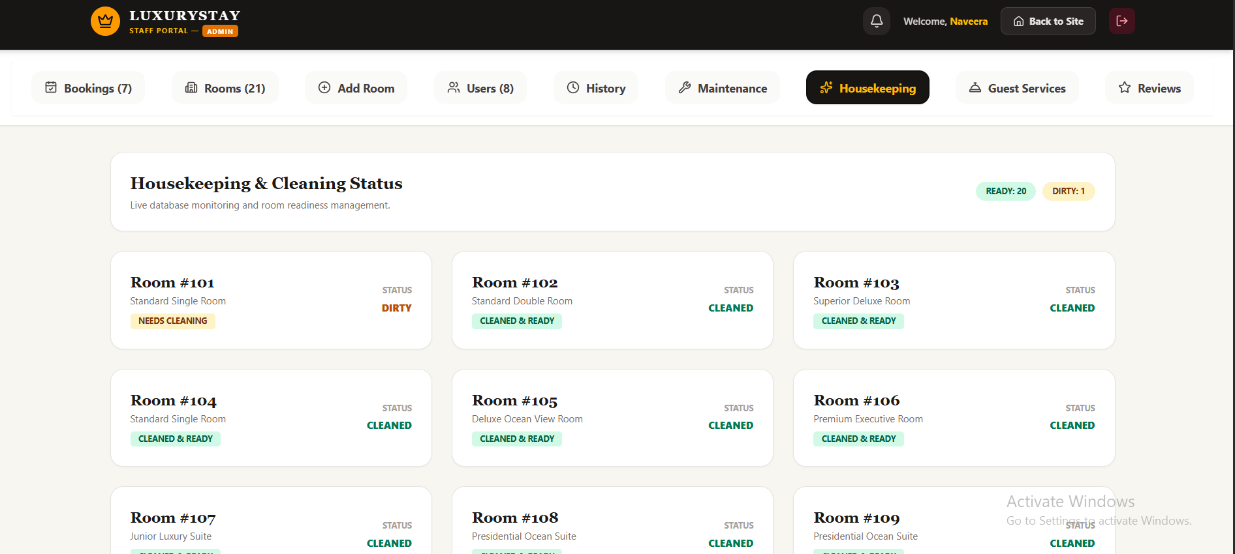

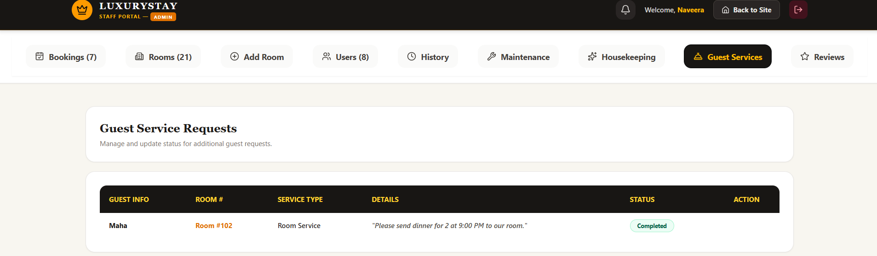

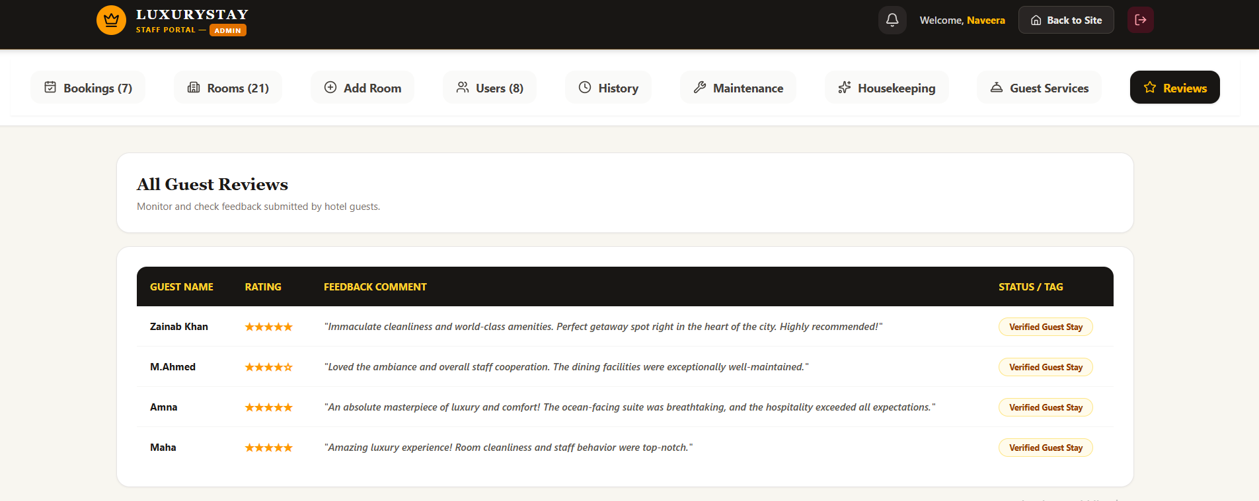

RECEPTIONIST:
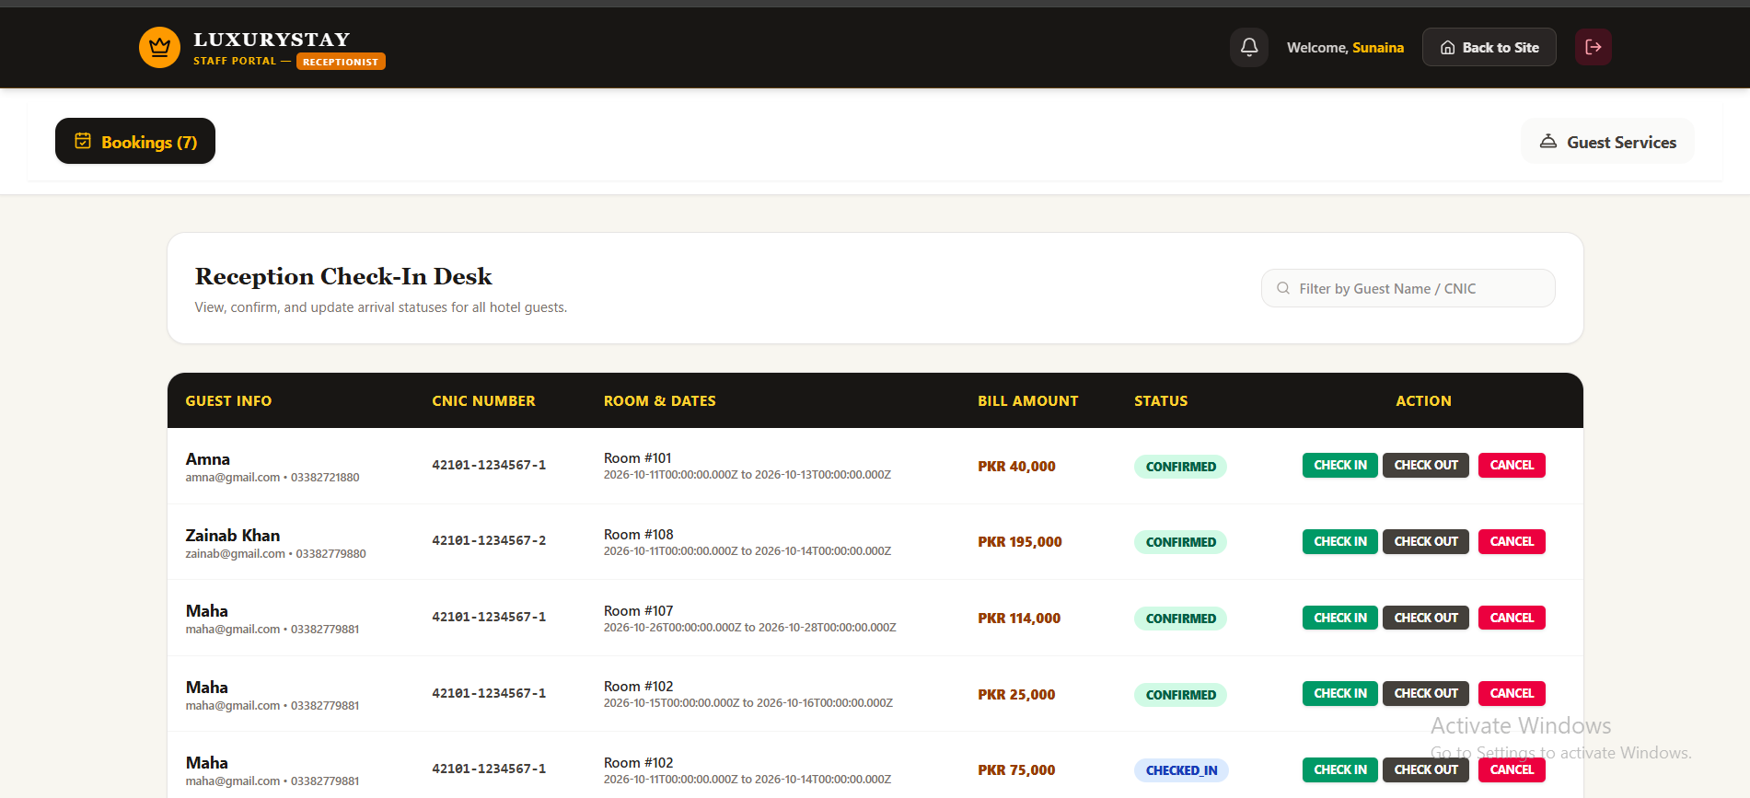

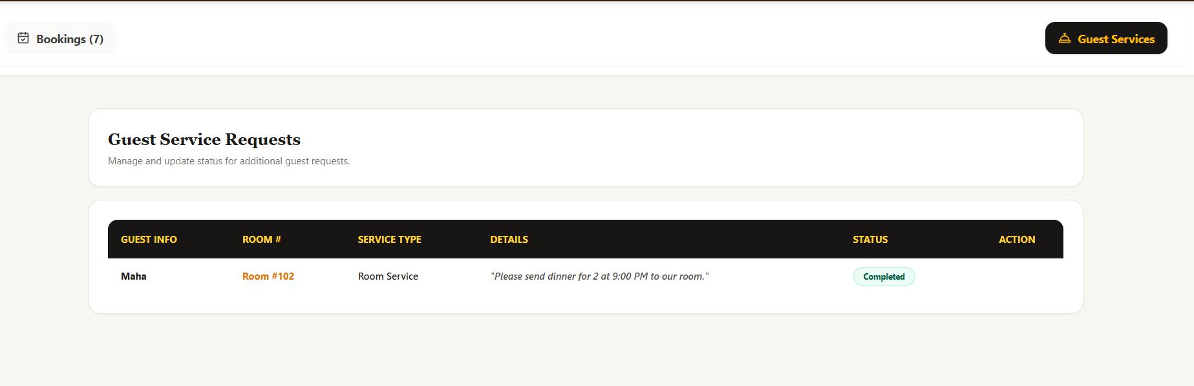

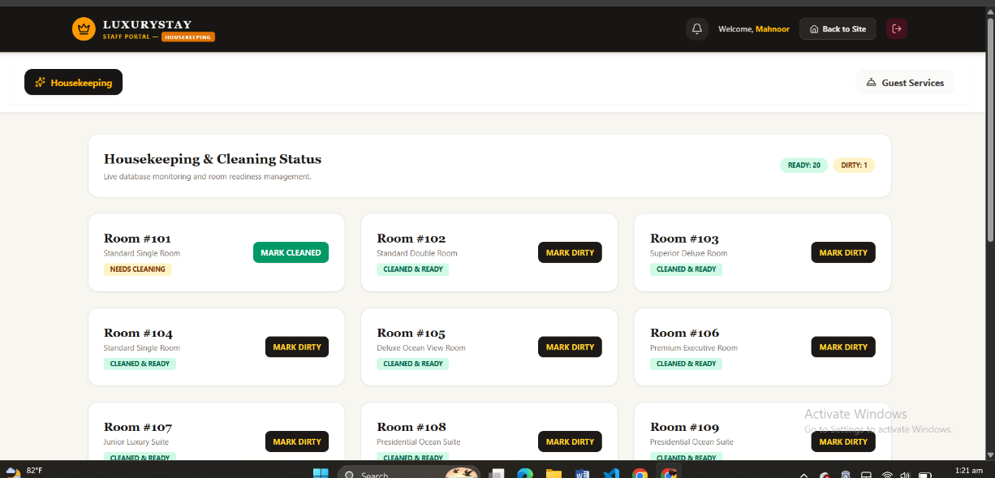
HOUSEKEEPING:

